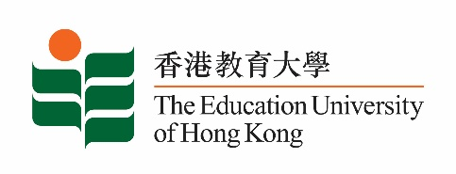
致： 传媒机构采访主任 (共 1页) 3 July 2020
To : News Editors (total: 1 pages)

香港教育大学2020年7月6日至19日可供采访之活动一览
The Education University of Hong Kong (EdUHK) Events Calendar for 6 to 19 July 2020
本校诚邀 贵机构派员采访下列活动。传媒查询，请联络教大邓慧仪小姐（电话：2948 6056 / 9181 4071）。
You are cordially invited to cover the events below. For media enquiries, please contact Miss Gloria Tang at 2948 6056 / 9181 4071.

因应2019冠状病毒疫情，以下活动或有人数限制，传媒请预先向主办部门登记。
In light of the COVID-19 pandemic, there may be restrictions on the number of participants for the following event(s). Please contact the respective organiser(s) / department(s) for prior registration.

- 教大大埔校园 （新界大埔露屏路十号） / EdUHK Tai Po Campus (10 Lo Ping Road, Tai Po, New Territories)

日期  Date | 时间  Time | 活动  Event | 地点  Venue | 主办部门及公众查询  Organiser &  Public Enquiry | 备注  Remarks
2020-06-27 -  2020-07-11 | 9 am – 7 pm | 畀啲颜色你睇 - 黎小威个展  Show You Some Colors – LAI Siu Wai Solo Exhibition | 教大大埔校园  文化与创意艺术学系展览厅（B2-P-01）  CCA Art Gallery,  EdUHK Tai Po Campus (B2-P-01) | 主办部门 / Organiser:  文化与创意艺术学系  Department of Cultural and Creative Arts  查询 / Enquiries:  黎小威先生Mr Arrow Lai Siu-wai  Tel /电话: 6475 0716 | 敬请预约  By appointment

