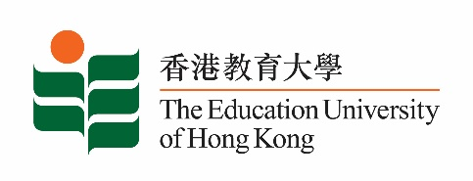
致： 传媒机构采访主任 (共 1页) 19 June 2020
To : News Editors (total: 1 pages)

香港教育大学2020年6月22日至7月5日可供采访之活动一览
The Education University of Hong Kong (EdUHK) Events Calendar for 22 June to 5 July 2020
本校诚邀 贵机构派员采访下列活动。传媒查询，请联络教大邓慧仪小姐（电话：2948 6056 / 9181 4071）。
You are cordially invited to cover the events below. For media enquiries, please contact Miss Gloria Tang at 2948 6056 / 9181 4071.

因应2019冠状病毒疫情，以下活动或有人数限制，传媒请预先向主办部门登记。
In light of the COVID-19 pandemic, there may be restrictions on the number of participants for the following event(s). Please contact the respective organiser(s) / department(s) for prior registration.

- 教大大埔校园 （新界大埔露屏路十号） / EdUHK Tai Po Campus (10 Lo Ping Road, Tai Po, New Territories)

日期  Date | 时间  Time | 活动  Event | 地点  Venue | 主办部门及公众查询  Organiser &  Public Enquiry | 备注  Remarks
2 July 2020 | 5.30 pm - 7.00 pm | 创造明日音乐：e-乐团音乐创演专业发展工作坊  Music Making of Tomorrow:  e-Orch Music Creation and Performance Professional Development Workshop  讲者：梁智轩博士  Speaker: Dr Michael Leung Chi-hin | 中环爱丁堡广场五号香港大会堂八楼演奏厅  Recital Hall, 8/F, Hong Kong City Hall, 5 Edinburgh Place, Central | 主办部门 / Organiser:  文化与创意艺术学系  Department of Cultural and Creative Arts  查询 / Enquiries:  梁卓朗先生  Mr Aaron Leung Cheuk-long  电邮 / Email: leungcl@eduhk.hk  梁智轩博士  Dr Michael Leung Chi-hin  Tel / 电话: 2948 7168 | 免费报名，欢迎各界人士参加。  Free Registration. All are welcome.  登记方法 / Registration: https://forms.gle/Wqhu8oy9VGvYsvh2A

