Interface Project for Promoting Creativity in Teaching

Final Report
Project leader: Cheng, Mo Yin Vivian
Members: Lee, How Chung & Kwan, Shi Pui

Objective
The main aim of this project is to promote a creative, flexible, imaginative, fun-emphasizing and self-actualizing culture in teaching. After the day, participants are expected to be equipped with some creative thinking and creative teaching strategies and the trained creative teachers can build up supporting circle among schools.
In July 03, Creative teacher day have been organized for different section of local teachers. On that day, teachers have experienced various funny and non-competitive teaching games and have learned some simple creativity-enhancing thinking strategies via the activities. After that day, teachers have been requested to finish series of follow-up activities including:
1. Creative teaching ideas competition
2. To be judge in the contest
3. School-based sharing
in order to consolidate the concepts learned on that day.

Working Time line

May, 03 | Promote the activities and Send invitation letter to principals of all schools
June, 03 | Collect the primarily creative teaching ideas from participants
12 July, 03 | Creative Teacher Day
July, 03 | Elaborate and diversify teaching ideas from participants for “Creative Teaching Ideas Competition”
August, 03 | Collect and assemble all creative teaching ideas  Send 1. Marking sheet to all participants  2. VCD recorded the whole day process,  Instruction for school-based workshop and report
September-November,03 | Collect marking sheets from participants
September-December, 03 | Collect school-based workshop report from participants
October, 03 | Invite a number of lecturers to be the judges of contest
November, 03 | Collect marking sheets from HKIEd lecturers
December, 03 | Send 1. Final results of Creative teaching ideas competition  2. Certificate to outstanding teaching ideas  3. Certificate to school and teachers who complete all the activities
January, 04 | Final Report

Participations
 | Kindergarten | Primary school | Secondary school | Total
Creative Teacher Day  (number of teachers) | 31 | 43 | 18 | 92
Creative Teacher Day  (number of schools) | 24 | 35 | 14 | 83
Creative teaching ideas competition  (number of ideas) | 18 | 35 (Mixed group) |  | 53
Judge in contest (number of teachers) | 17 | 24 |  | 41
Judge in contest (number of HKIEd lecturers) | 2 | 4 |  | 6
Books/ CDs/ other materials sharing  (number of teachers) | 2 | 5 | 3 | 10
School-based sharing  (number of teachers) | 18 | 28 | 4 | 50

Details of activities
Preparation and Promotion: (May, 2003)
- Send the invitation letters to the principals of all kindergarten, primary and secondary schools in Hong Kong
- Each school selects teacher representatives to join the Day
- Each participant submits creative teaching ideas designated by themselves
- A panel of lecturers select the participants based on their submitted ideas to join the Day
- All schools and participants should promise to organize a school based workshop after the Day

Creative teacher Day: (12 July 2003)
- All participants are divided into 1 Kindergarten group and 2 mixed groups (primary and secondary schools). They have chance to share their submitted teaching ideas in groups. Each group selects the best teaching ideas within the group and further elaborates it. After each group presents their teaching ideas and the whole class nominates the best one.
- Some creative thinking strategies are taught through different activities for enhancing the creativity in teaching.
- Some creative teaching ideas are selected to present. The prizes are awarded to the winning groups

Creative teaching ideas competition: (July to November, 2003)
- All participants are encouraged to extend and elaborate their teaching ideas to join the Creative teaching ideas competition
- All modified teaching ideas are collected and packed to a booklet
- The booklet and marking sheet are sent to all participants of the Day and invite all of them to mark
- The teaching ideas are also evaluated by experienced lecturers of our institute
- The weigh of marking is 1:1 to participants and lecturers
- Certificates are granted to outstanding teaching ideas
- All of these ideas are planned to be published on the web
Comment on Creative teaching ideas competition (The comments are collected from the evaluation test distributed to all participants in December)
- I have learned some thinking skills that can be used for promoting creativity
- Enhanced my own creativity
- There are some changes in my teaching lessons
- Self-reflect about my lesson whether it is creative
- More interested in teaching on creative way after put my teaching ideas into practice
- Break through from original teaching styles
- It is a chance to try out divergent thinking skills
- Provide a room to try out different ways of teaching
- Believe that I am able to teach in creative way
- Build up self-confidence on creative teaching
- My teaching idea is recognized by others

Comment on Being Judge in Creative teaching ideas competition (The comments are collected from the evaluation test distributed to all participants in December)

- Benefit by others teaching ideas and experiences
- Benefit by mutual appreciation
- Get experience on how to judge a teaching idea/ Insight on what creativity is
- Personal judgment on the ability of creativity in teaching
- (Inspiration) Promote myself to try out something different
- New notion on what creativity is
- Enhance the ability on creativity
- Get more insight on the weakness of my teaching via judging other teaching ideas

School-based Sharing: (September to December, 2003)
- Participants are encouraged to bring back what they have learnt to the school
- All teaching ideas, the rundown booklet, the CDs recording the whole day process and a set of reference books are distributed to all participants for a aid of organizing the workshop
- Participants are requested to organize the workshop in the school
- Certificates are granted to the schools and teachers who complete all the activities

Comment on School-based sharing (The comments are collected from the evaluation test distributed to all participants in December)

- More confidence on creativity
- Believe that everyone have potential on creativity
- Consolidate the concepts that have been learned
- Have chance to share my own creative teaching idea to my colleagues
- Bring the idea of creative teaching into school level and then into student level
- Publicize creative teaching.

Feedback from the participants’colleagues who attended the school workshop (The comments are collected from the School-based sharing Reports from some participants)
:
The participants’colleagues generally comment on workshop/ creative teaching:
- Fresh
- Interesting
- Know more about “creativity “
- Willing to try in the lesson
- Useful for planning the curriculum
- Positive on the effectiveness of creative teaching
- Adopt to the cross-curriculum

Styles of school-based sharing:
We have allowed teachers to decide any kinds of school-based sharing. The teachers who have finished the sharing needed to hand-in their reports and then they have been rewarded a merit certificate. Generally, the styles of school-based sharing can be divided into two types: They are group sharing or material distribution. The teachers either held their sharing for whole school or just a few teachers sharing. The formats they presented included
1. Using PowerPoint presentation to introduce what they have learned on creative teachers’ day
2. Sharing the creative teaching ideas or video recorded on that day to their colleagues. Some teachers also designated some interactive games in order to introduce the element of creativity and the thinking strategies to their colleagues.

Difficulties encountered:
Due to the outbreak of SARS in Hong Kong, the schedules of whole project have been delayed as below:
Planned tasks | Change in time
1. Creative Teacher Day | June 03 → July 03
2. School-based sharing | July 03 to November 03  → October 03 to December 03
3. School-based sharing Report | August 03 → December 03

The outbreaks of SARS in Hong Kong have impacted on the teaching schedules in most school. The summer holiday have been delayed and shortened. Thus some participants have difficulties to finish the school-based sharing. We have adjusted the deadline of school-based sharing report in order to allowed more teachers to hold the sharing in their schools.

Future Plan

Funding would be seek to support related research and publications:
- Research
To Study the effectiveness of various strategies in enhancing creativity in teaching. (Some written comment from participants are listed in former paragraphs)
- Publications
Some teaching ideas have been modified and collected. The ideas would be decided to publish in existing web-page or gather into books in the future.

Photos on the Creative Teacher Day

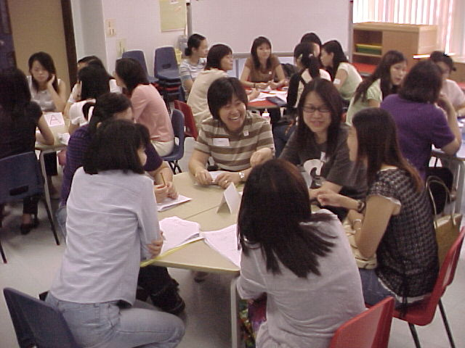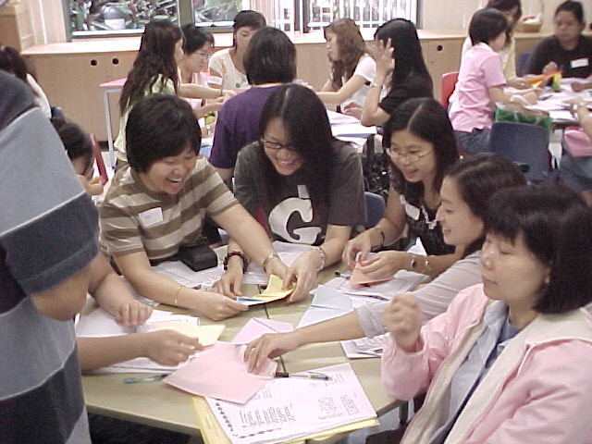
Sharing their teaching ideas Playing the class activities
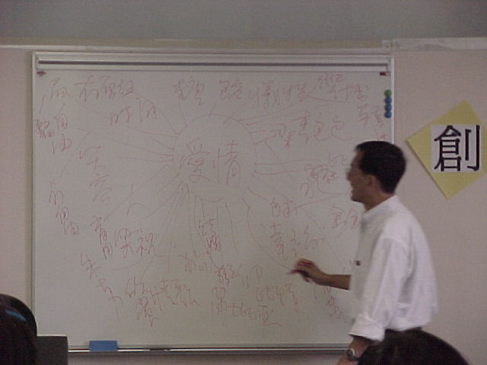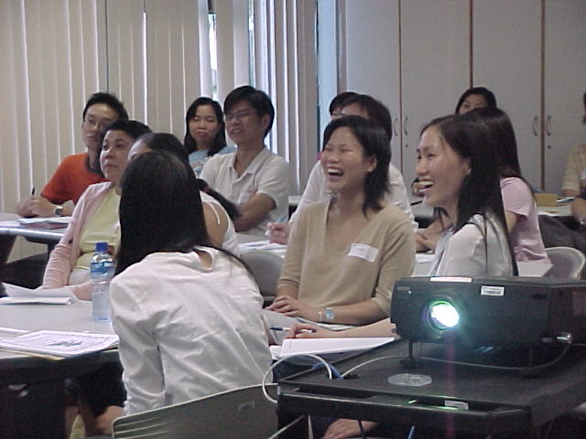
Introducing “Mind Map” Involved in the activity
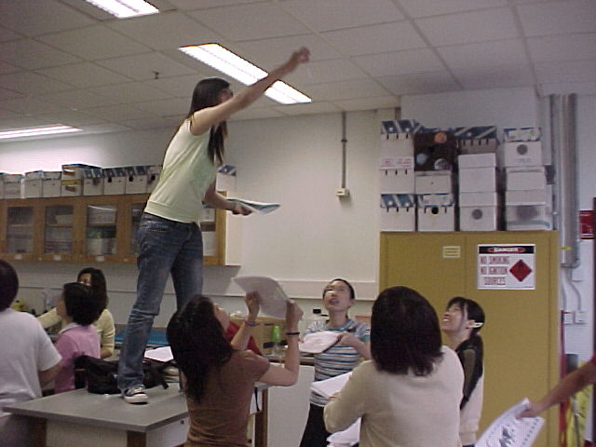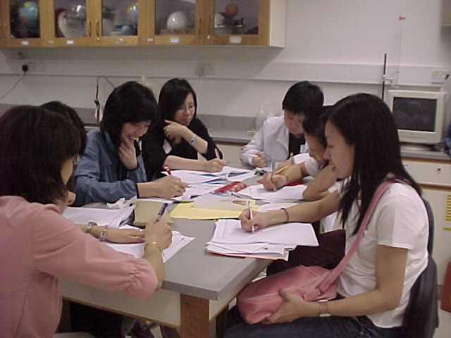
A game “Stirring up the paper” Using different strategies on thinking

Appendix Lists

- Photos on the Creative Teacher Day
- Promotion Items
- Application Form
- Booklet
- Marking Sheet
- Competition Results
- School-based sharing guidance and report
- Merit certificate
- Samples of school-based sharing report

