Baptist Lui Ming Choi Secondary School

F. 5 Physics

Circuit Worksheet 1

Finish the following tasks with the aid of Electronics Workbench Demo.
Consult the handout Electronics Workbench Demo reference when required.

Task 1 Resistance of a resistor
Change the internal resistance of the ammeter and voltmeter to be 1 Ω and 1 kΩ respectively.
Change the resistance of the resistor R to be 500Ω.
The battery is of 12 V. With the aid of Electronics Workbench Demo connect up the following circuits and
calculate the resistance of the resistor R (= 500 Ω) using the readings measured by the meters..
Circuit A Circuit B
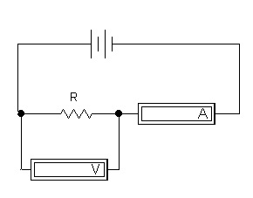
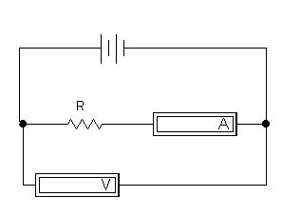
V = __________ V V = __________ V
I = ___________ mA I = ___________ mA
R = $\frac{V}{I}$= _____________Ω R = $\frac{V}{I}$= _____________Ω
Which circuit give a better value of R (closer to the real value of R) ? Circuit _______

Reasoning
R_{v} – internal resistance of the voltmeter R_{v} – internal resistance of the ammeter
I_{r} – current passing through the resistor V_{r} – voltage across the resistor
I_{v} – current passing through the voltmeter V_{a} – voltage across the ammeter
For circuit A : For circuit B :
(1) Ammeter measures the current through R and (1) Voltmeter measures the voltage across R and voltmeter ammeter
(2) Voltmeter measures the voltage across R (2) Ammeter measures the current through R
(3) When R ≅ R_{v} (in order), I_{r} ≅ I_{r} (same V), (3) When R >> R_{v}, V_{r} >> V_{a} (same I),
so the measured I (=I_{r} + I_{r}) > I_{r}, and so measured V (=V_{r} + V_{a}) ≅ V_{r}, and
calculated R (= V / I ) is smaller than the real R. calculated R (= V / I ) is close to real R
.
Now the calculated R is of the order of hundred Ohm, close to the internal resistance of the voltmeter and much greater than the internal resistance of the ammeter, so circuit ________ should be used.
When R is close to the internal resistance of ammeter and much smaller than internal resistance of voltmeter, circuit __________ should be used. (Why?

Task 2 Change in ammeter and voltmeter reading in different circuits
Change the internal resistance of ammeter and voltmeter to be 1 MΩ.
Put down increases, decreases or unchanged for statements 1 – 8 when the switch S1 in circuit
A and B are opened.
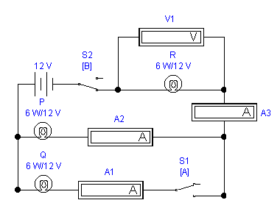
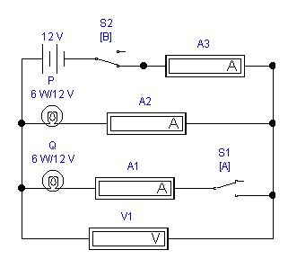
Circuit A Circuit B

Circuit A Circuit B
- The reading of ammeter A1. ____________ ____________
- The reading of ammeter A2. ____________ ____________
- The reading of ammeter A3. ____________ ___________
- The reading of the voltmeter V1. ____________ ____________
- The brightness of bulb P. ____________ ____________
- The brightness of bulb Q. ____________ ___________
- The brightness of bulb R. ------ ____________
- The power output from the battery. ____________ ____________
- When switch S2 in circuit A and B are opened, what should be the readings in all the
meters? _____________
Explain the above in terms of the connection of the circuits (simple parallel, a mix of series and parallel).

END OF WORKSHEET

