Baptist Lui Ming Choi Secondary School

F.3 Physics
Circuit Worksheet 1

Finish the following tasks with the aid of Electronics Workbench Demo.
Consult the handout Electronics Workbench Demo reference when required.
All cells are of 1.5V. All bulbs are of 6V, 2.5W.
Task 1 Voltage across a cell and current in a circuit
Measure the voltage across the cell and the current passing through the bulb in the following circuit. Draw
the required circuit diagram in the space provided and fill in the blanks. Mark the positive and negative
terminals of the meters in the diagram.
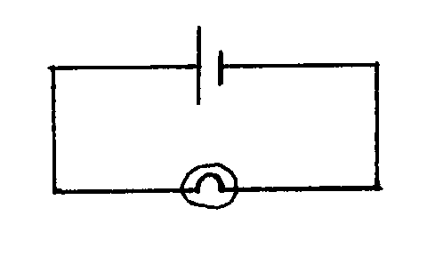

Voltage across the cell = _______ V
Current in the circuit = ________ mA
A voltmeter should be connected in ______________ to a component in order to
measure the voltage across the component. (series/parallel)
An ammeter should be connected in ______________ to a component in order to
measure the current passing through the component. (series/parallel)

Task 2 More than one cell in series
Measure the voltage across the cells A and B (V_{ab}), across the cells B and C (V_{bc}). Then measure the voltage
across the cells A, B and C (V_{abc}).

(1) All cells are in the same direction (2) Cell B is in the opposite direction
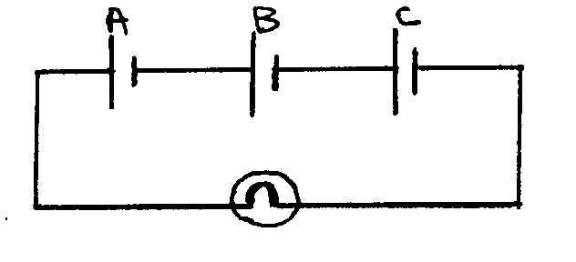
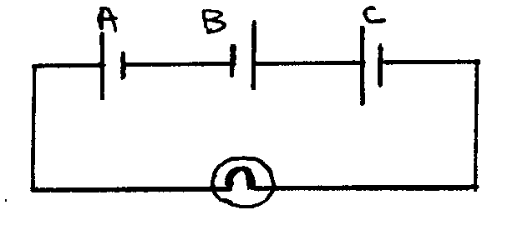

V_{ab} = ________V, V_{bc} = _______ V V_{ab} = _______ V, V_{bc} = _______ V, V_{abc} = _______ V V_{abc} = _______ V
When all cells are in the same direction, V_{abc} = V_{a} _____ V_{b} ______ V_{c} (+/-)
When cell B is in the opposite direction, V_{abc} = V_{a} _____ V_{b} ______ V_{c} (+/-)

Task 3 Current in a circuit when the voltage increases
Measure the voltage across the bulb and the current in the circuit A, B and C.
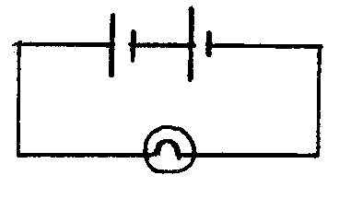
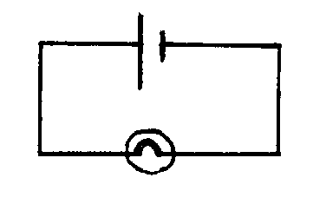
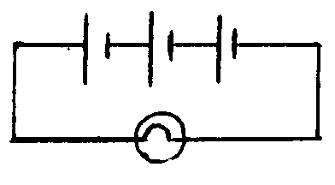
Circuit A circuit B circuit C
V_{a} = _____________ V V_{b} = _____________ V V_{c} = _____________ V
I_{a} = ____________ mA I_{b} = _____________ mA I_{c} = _____________ mA
The current in a circuit ________________ as the voltage increases.
(increases/decreases)

Task 4 Current and voltage in a simple series circuit
Measure the current at position P, Q, and R. Measure the voltage across the bulb A and B.
current at P = _______ mA, current at Q = _______ mA
current at R = _______ mA,
voltage across A = ________ V
voltage across B = ________ V
voltage across the cell = ________ V

The current is _________________ at different positions of a simple series circuit. (the same/ different)
The voltage of a battery is the _________________ of the voltage across all the other components in a simple series circuit. (sum/ difference)

Task 5 Current and voltage in a simple parallel circuit
Measure the current at position P, Q and R. Measure the voltage across the bulb A and B.
current at P = _______ mA, current at Q = _______ mA
current at R = _______ mA,
voltage across A = ________ V
voltage across B = ________ V
voltage across the cell = ________ V

The voltage is _________________ in different branches of a simple parallel circuit. (the same/ different)
The total current in a circuit is the _________________ of the currents in all the branches in a simple parallel circuit. (sum/ difference)

END OF WORKSHEET

